SIMVOLY CODE EMBED

I have learnt two ways to embed code on simvoly website.

Method1: To embed the code on a page: I have used this method to embed the calculator.

1. Drag the code embed </> feature from widgets.

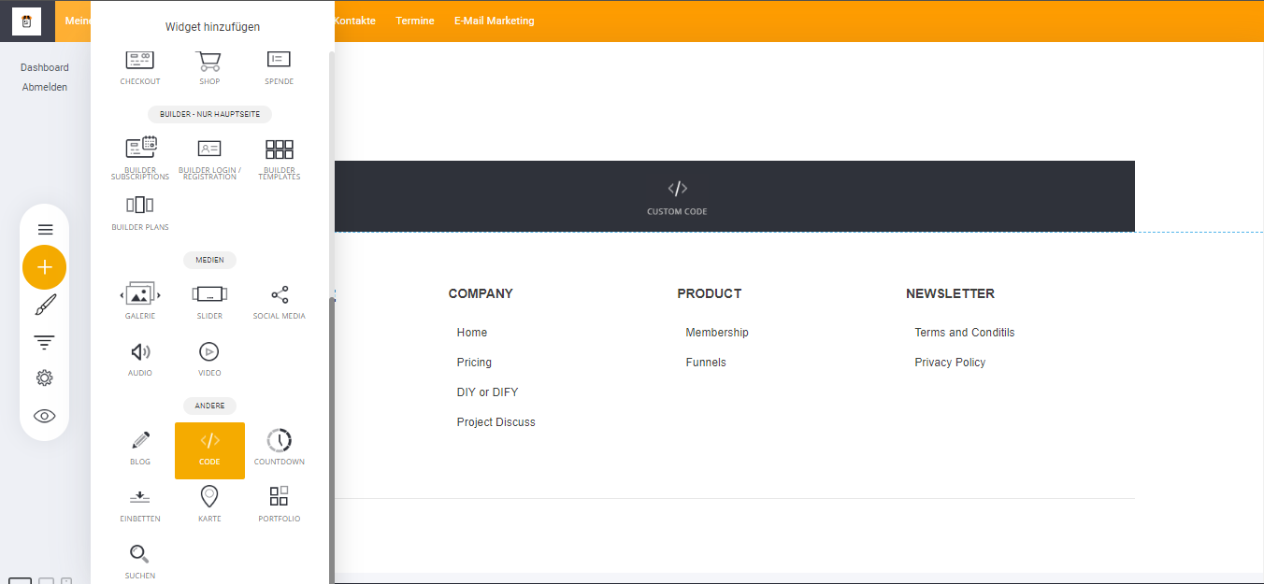

1. The setting should be set to HTML.

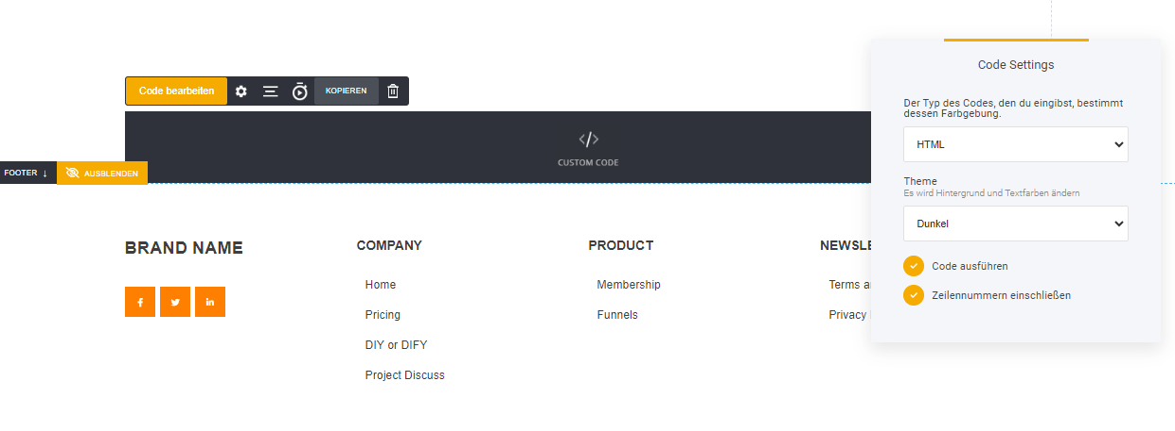

1. Paste the code into the editor.

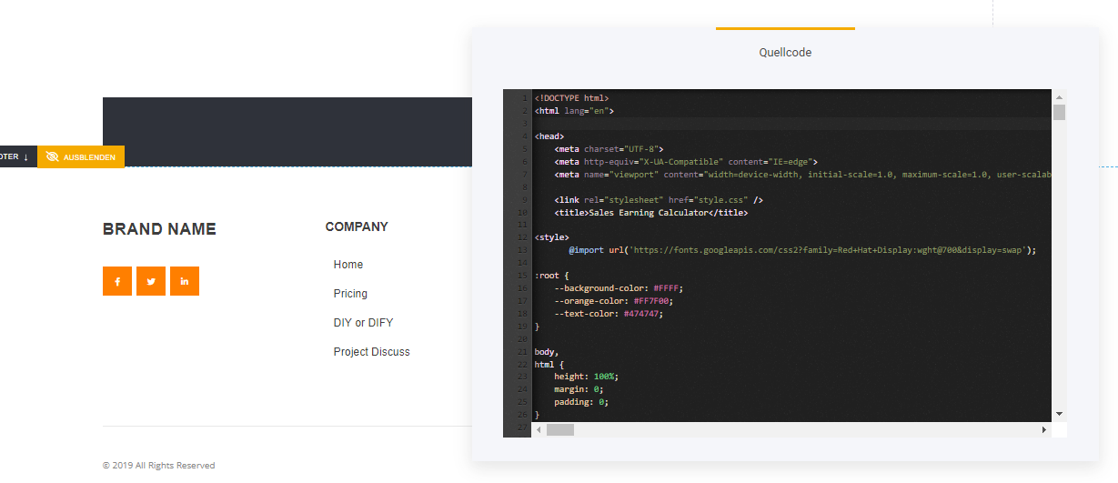

Method 2:

1. Open custom code section in SETTINGS.

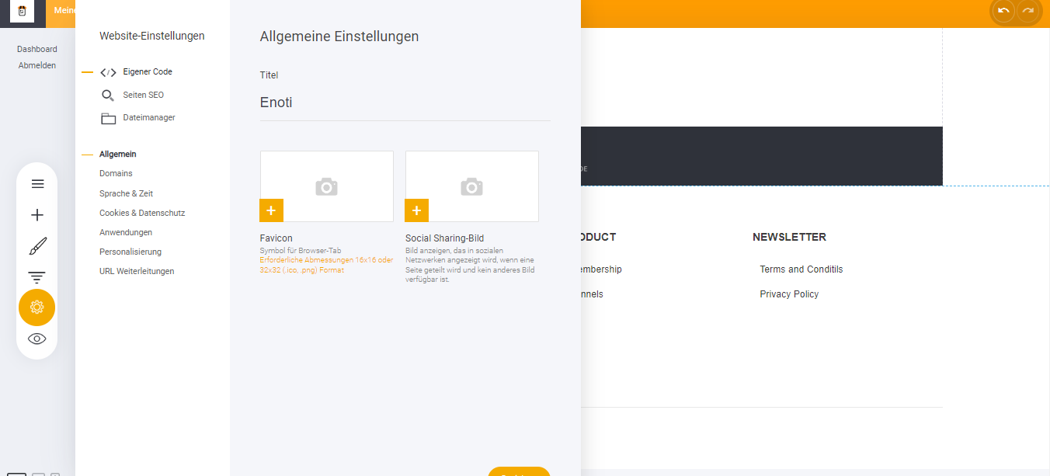

The previous method takes code in a single file. (HTML, CSS AND JS). This method takes code separately.

1. Seiten CSS (CSS code), Seiten Head Markup (JS code), Seiten Body Markup (HTML code). Upper section is to embed globally (all pages of website). Lower section is to embed on a single page.

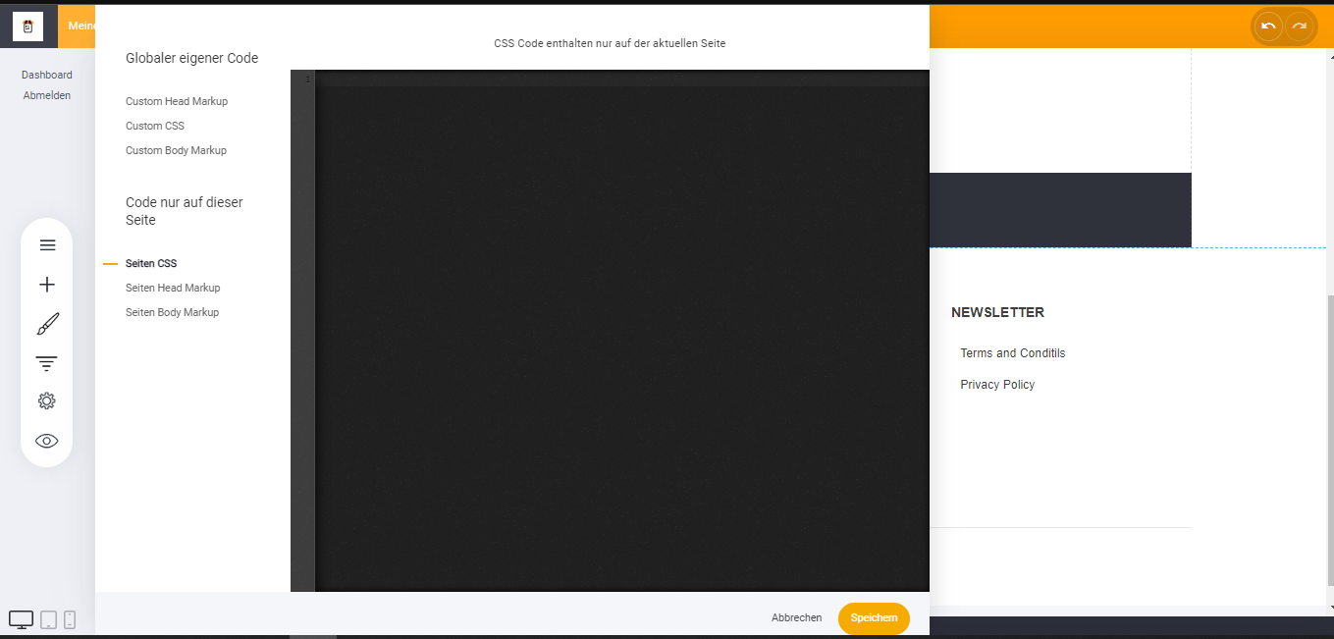

\*You can ask your developer to provide you with a single code file or separate files based on your choice of methods.